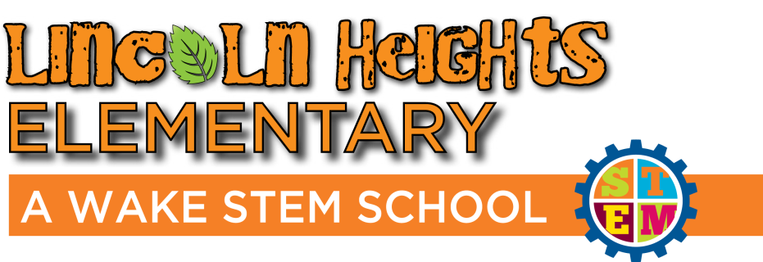
Business Partnership Form
Name: ___________________________________
Company: ________________________________
Job Description:

What is your availability? (Dates/Times to come to our school)

Are you willing to present to a class?
Yes No
Are you comfortable presenting to larger groups of students?
Yes No
Do you have a favorite children’s book related to your job field?
Yes No
If yes, would you be comfortable reading this book to a class?
Yes No

How do you solve problems at your work that could correlate with our Engineering Design Process model?

*Please note: If the location of our school is inconvenient, we are happy to set up Virtual conferences/field trips at your request.*

Please scan and email this completed form to the Lincoln Heights STEM Coordinator, Erica Prentice at eprentice@wcpss.net . An electronic version of this form is also available on our STEM website at lhstem.weebly.com.

We look forward to working closely with you for the benefit of our students!
Sincerely,
Erica Prentice
STEM Coordinator
Lincoln Heights Elementary School

EMAIL: eprentice@wcpss.net
STEM WEBSITE: www.lhstem.weebly.com
SCHOOL WEBSITE: http://lincolnheightses.wcpss.net/
ADDRESS:
307 Bridge Street
Fuquay-Varina, NC 27526
(919) 557-2590

